1. Winterization of different generators/plants

File BES_Winterization

Line no 189-193

These are weatherization values in MW

We need to change these and check if ENS is reduced

1. HDVC Flow ties : Line no 431

These are ties values (meaning ability to borrow energy from other sources)

These can be modified in line 183 - 186

Result : OPF result - magnitude + directions : Line 449

If OPF fails, load shedding

OPF succeeds : Load shedding is reduced

1. Demand Response Line 253 , 586 (dr_cap, dr_shed, dr_area)
2. Storage Line 249

3, 4 are currently 0, we need to look for the units and update it to non zero

We should be able to generate something like this after comparison:

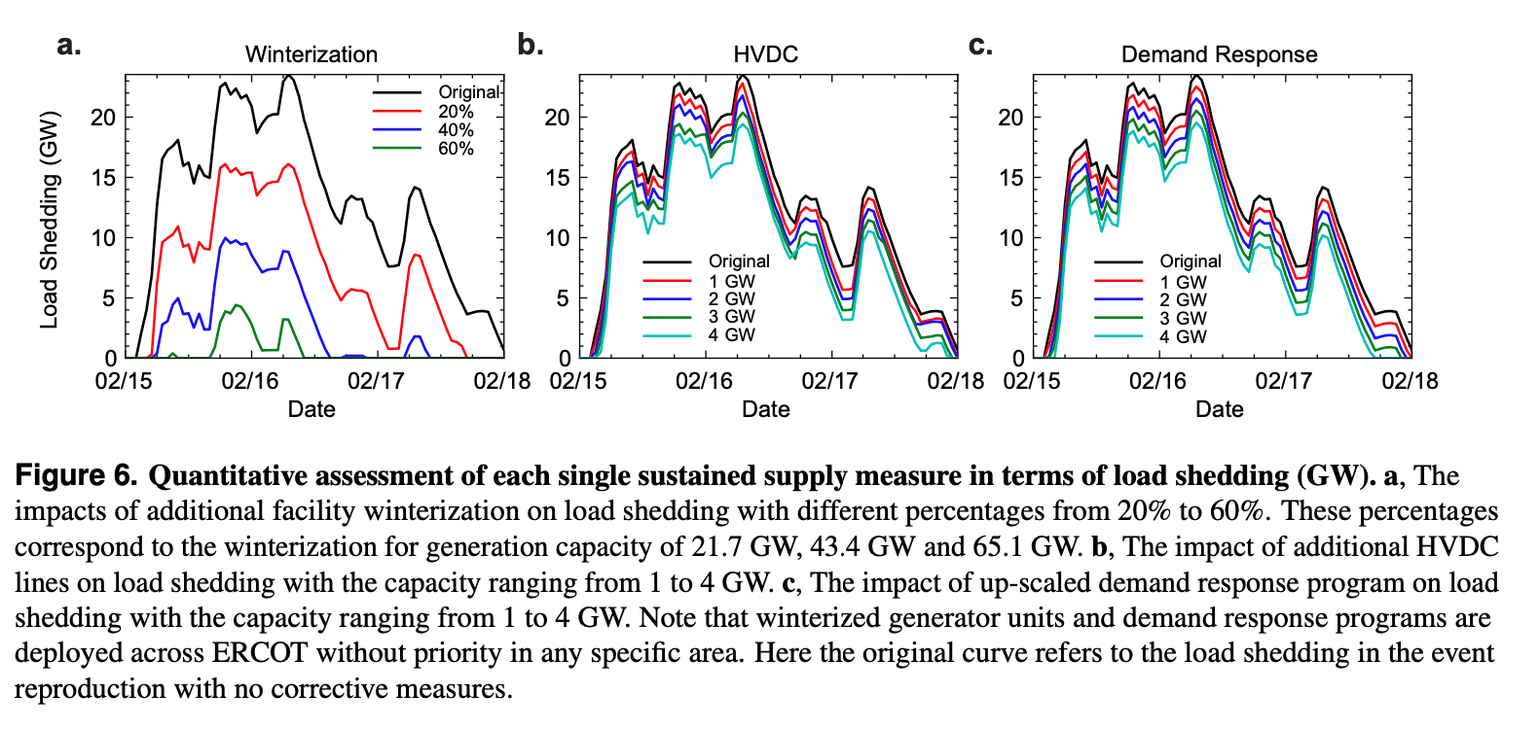

Initial Image:

Total Load Shed in MWh:

9.2051e+05

Reduced Load Shed in MWh:

9129

Peak Load Shed in MW:

23530

Load Shed Duration:

70

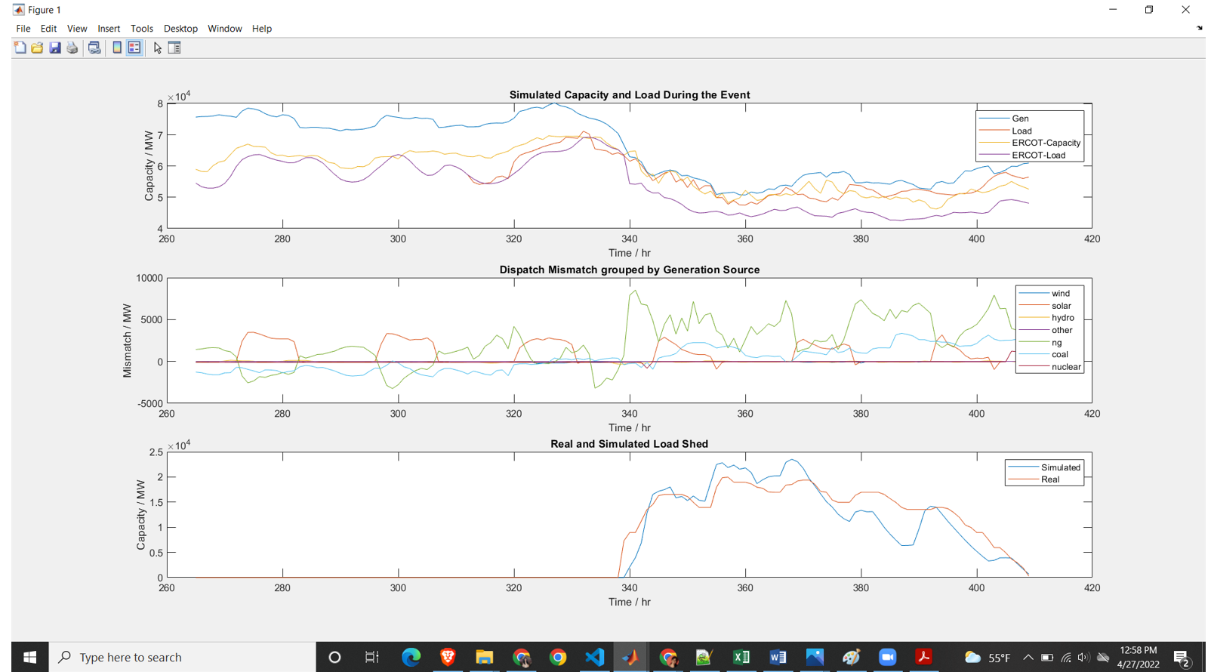

After changing the Winterization values

Flowchart of Iterative load shedding in simulation

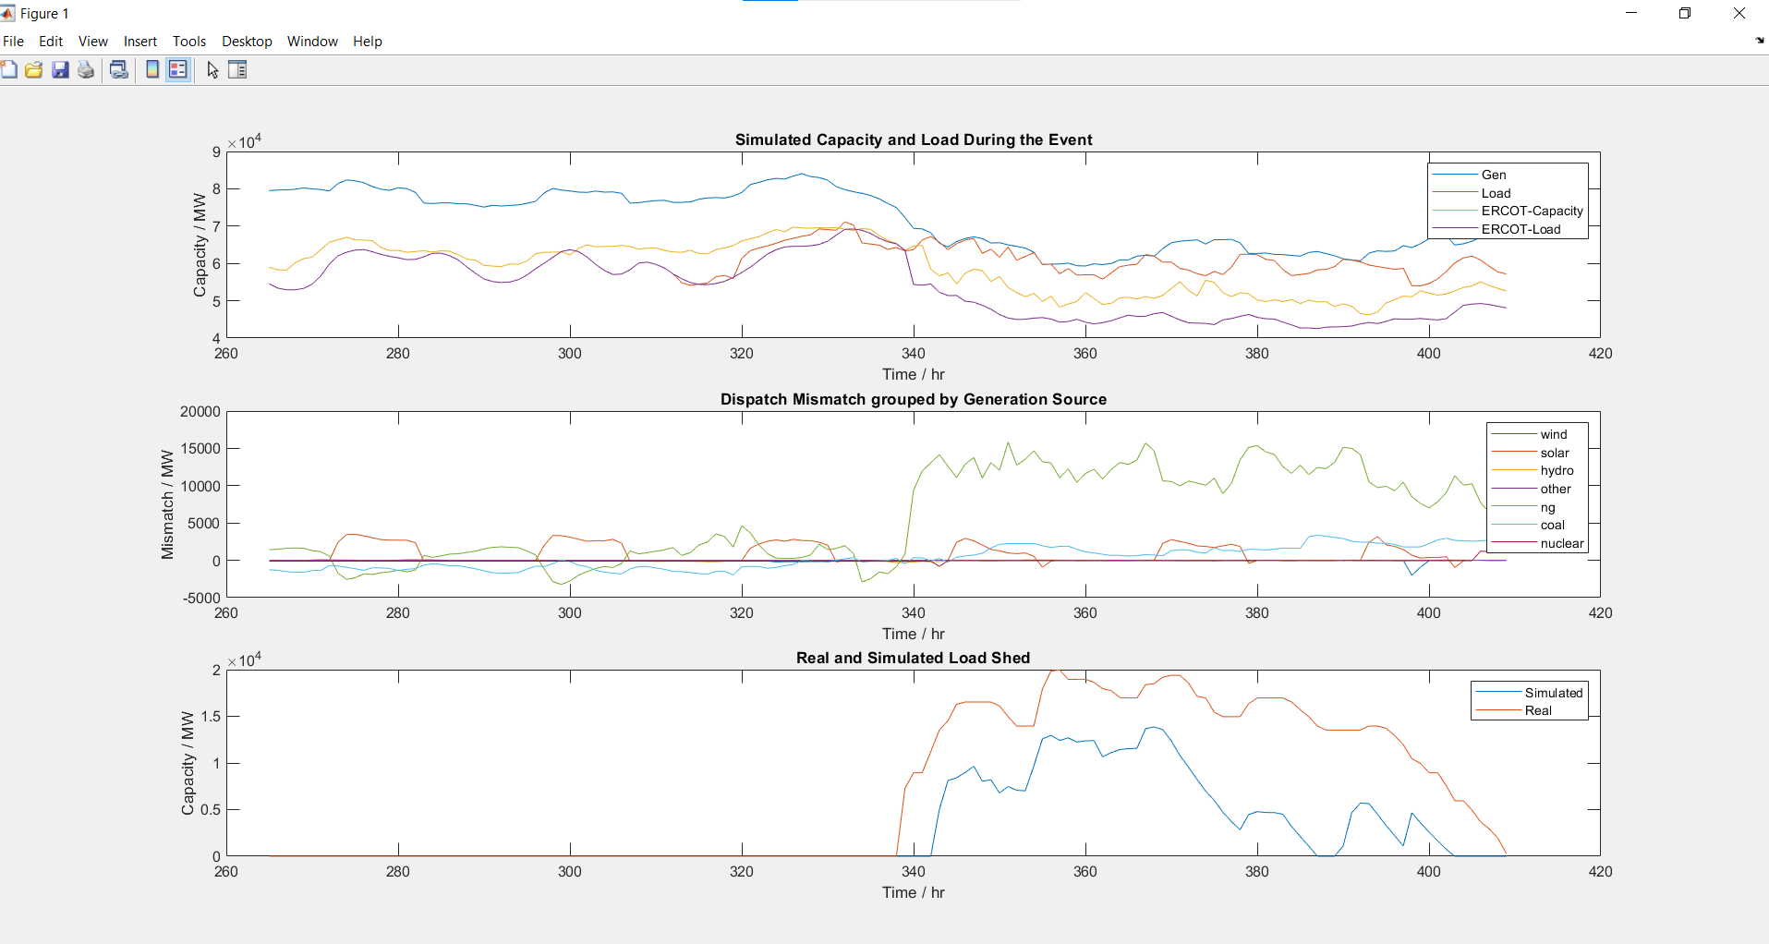

There is so much difference between Simulated and Real

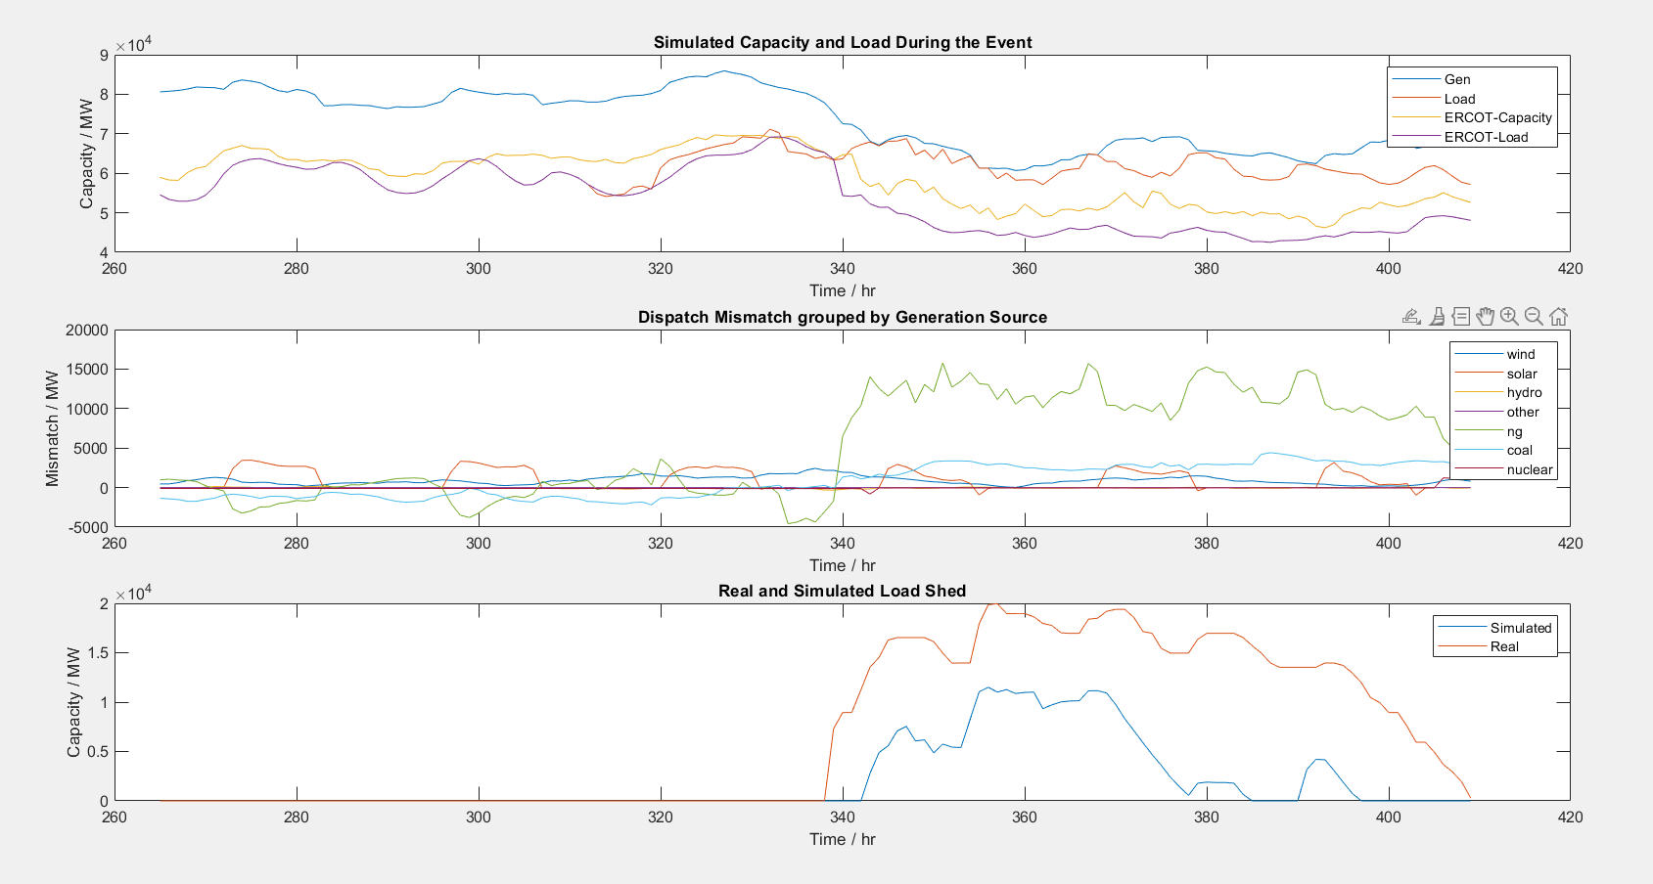

**Changed all WInterization values**

I uncommented these lines and ran the code

Total Load Shed in MWh:

3.4597e+05

Reduced Load Shed in MWh:

583670

Peak Load Shed in MW:

12254

Load Shed Duration:

56

**Changing the Winterization Wind:**

Total Load Shed in MWh:

8.6326e+05

Reduced Load Shed in MWh:

66384

Peak Load Shed in MW:

22203

Load Shed Duration:

69

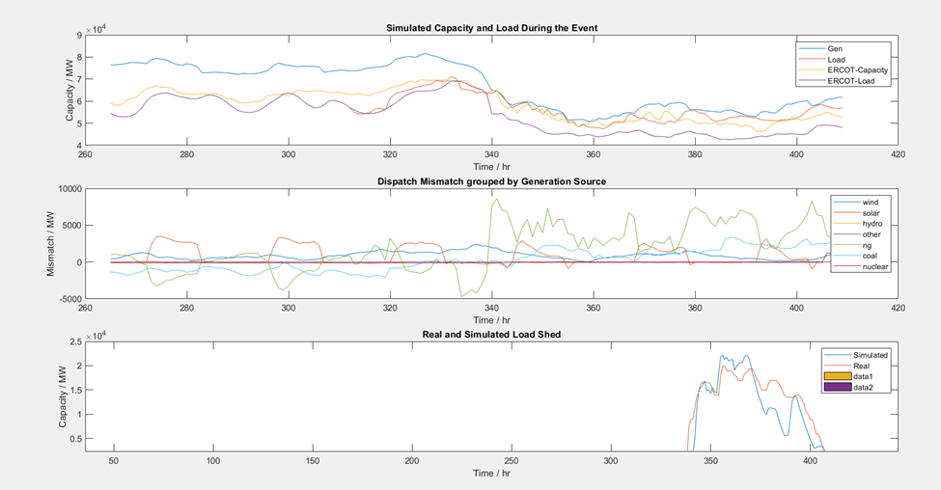

**Changing the Winterization Coal:**

**Total Load Shed in MWh:**

**8.2990e+05**

**Reduced Load Shed in MWh:**

**99742**

**Peak Load Shed in MW:**

**21502**

**Load Shed Duration:**

**69**

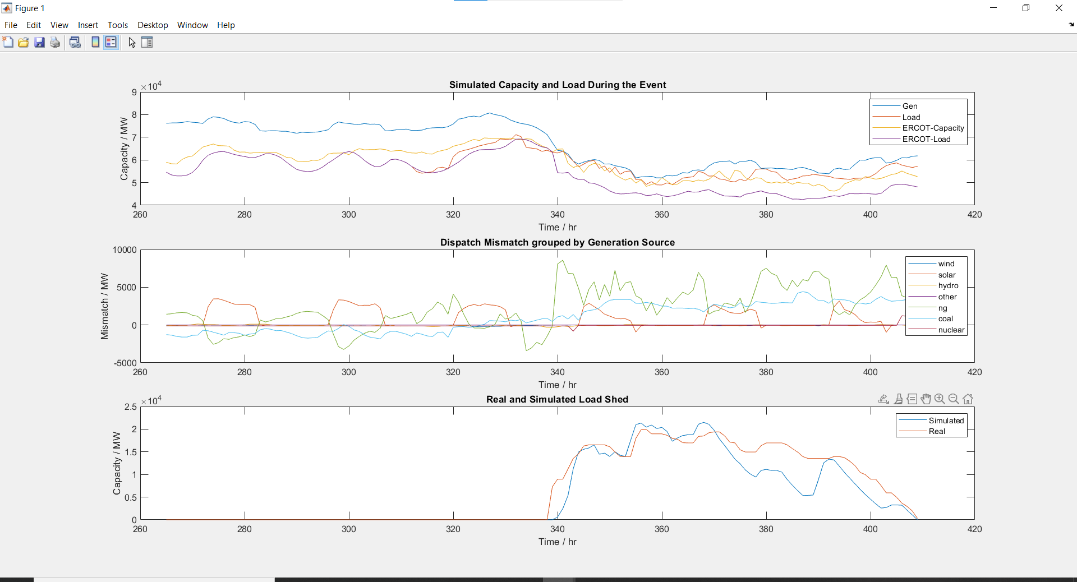

**HVDC enablement**

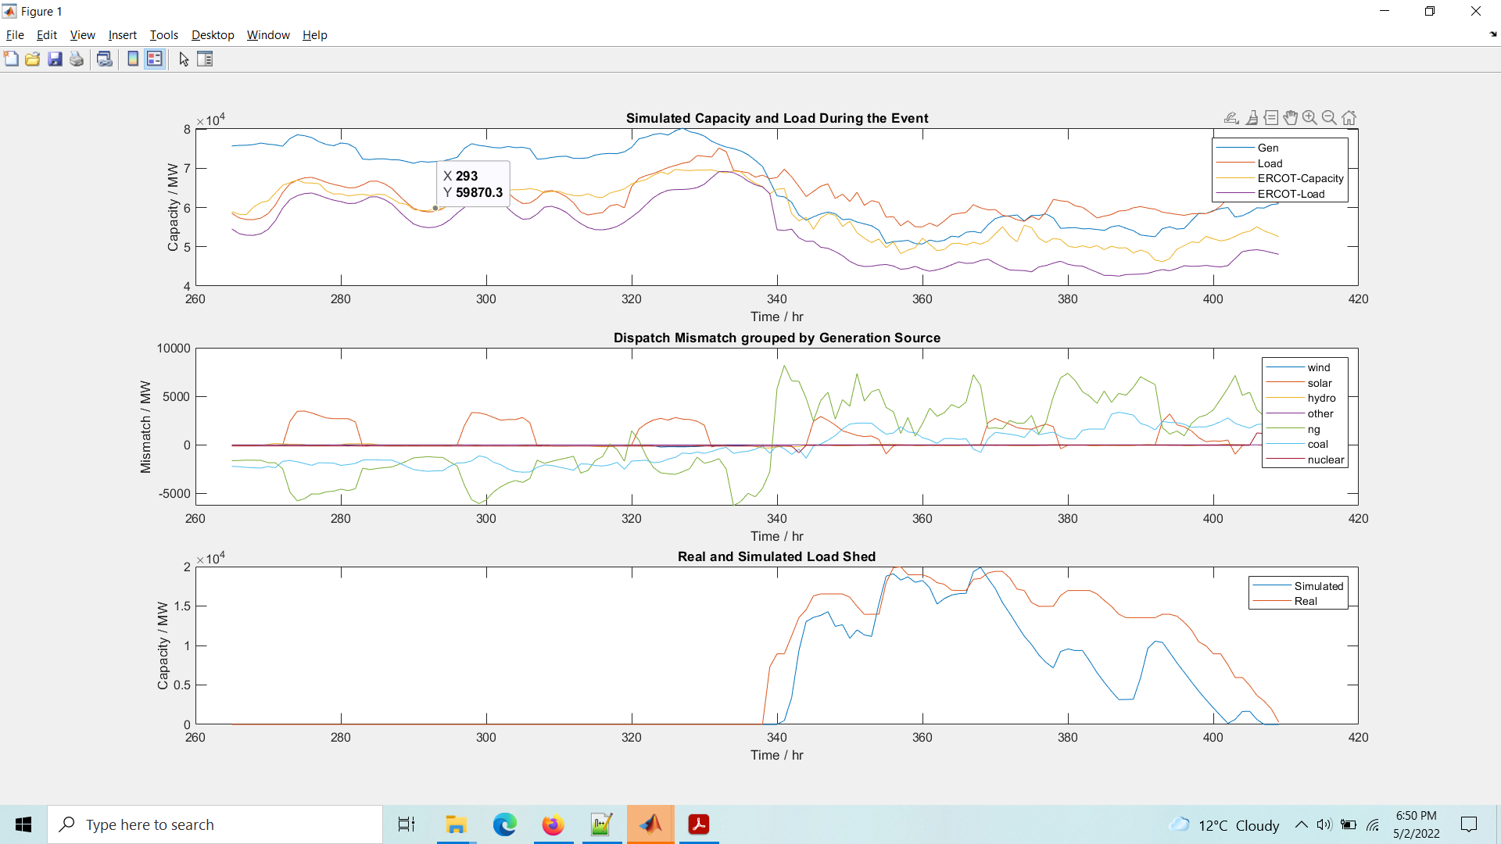

Total Load Shed in MWh:

6.7683e+05

Reduced Load Shed in MWh:

252811

Peak Load Shed in MW:

19896

Load Shed Duration:

66

Simulated load shedding tracks closely for earlier dates, but it drops down sharply. We need to explain why this trend occurred.

Changing Natural Gas values(3500 500 1000 1000 2500 3000 1000 2500)

Total Load Shed in MWh:

5.3502e+05

Reduced Load Shed in MWh:

394620

Peak Load Shed in MW:

16757

Load Shed Duration:

59

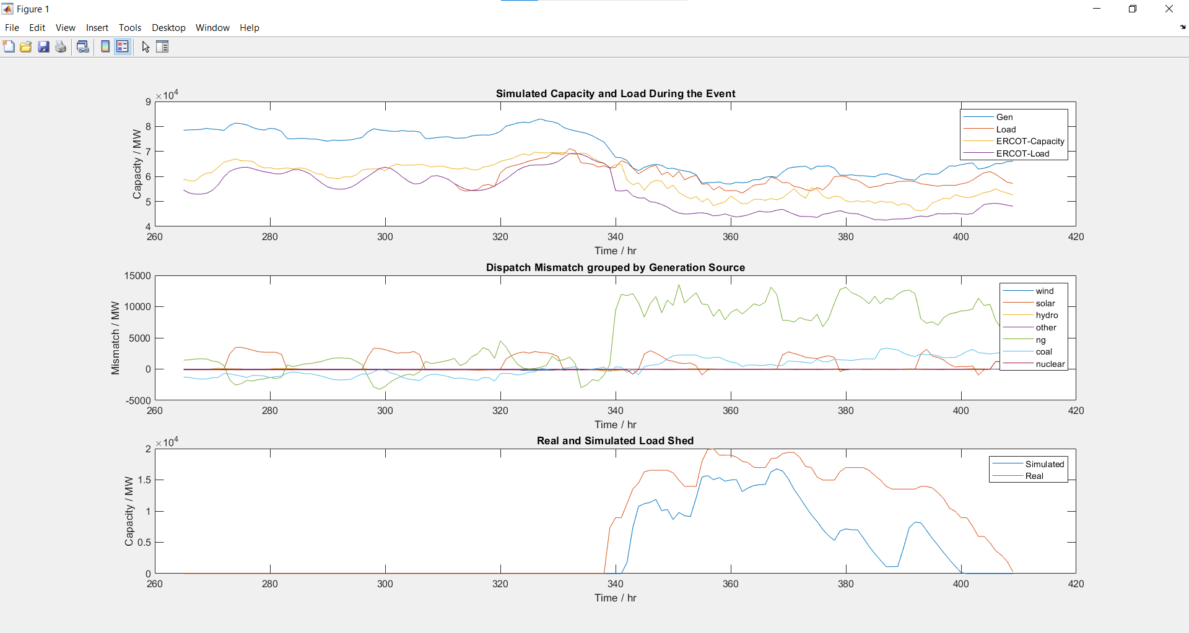

Changing all Values as per Report:

Total Load Shed in MWh:

4.8800e+05

Reduced Load Shed in MWh:

441637

Peak Load Shed in MW:

15390

Load Shed Duration:

58

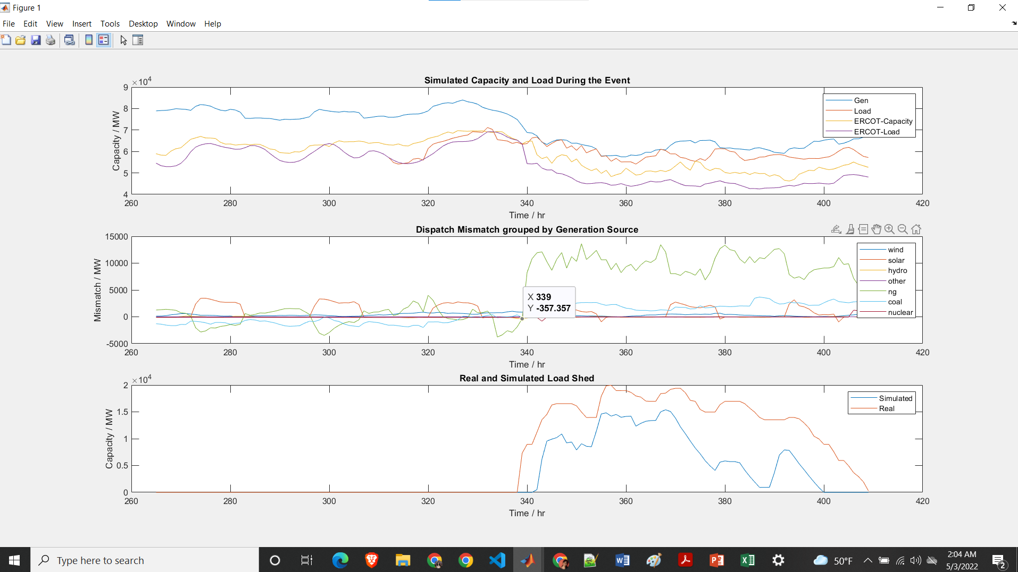

Last two plots with HVDC enablement:

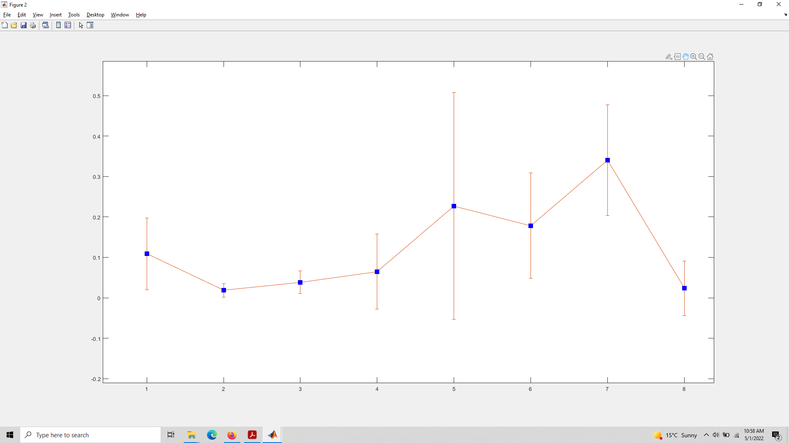

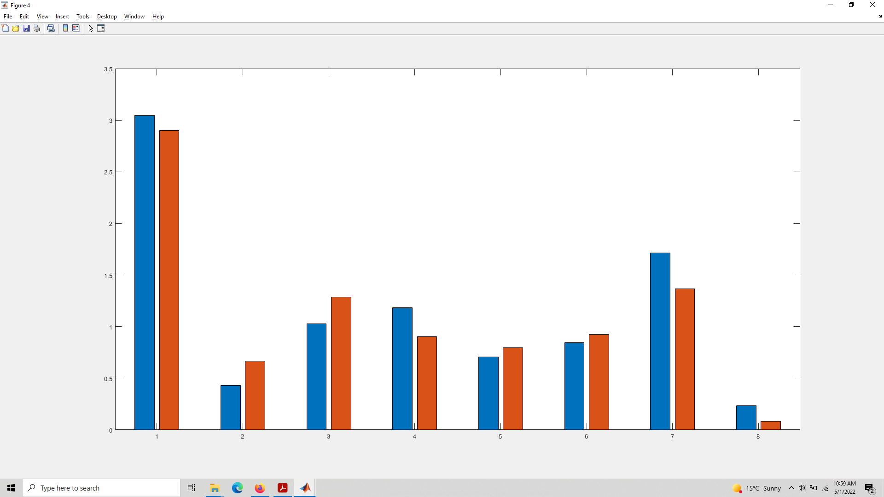

Red = real, blue = ercot

I don’t understand why they call it “real”, and not “simulated”

**Demand response**

**3GW:**

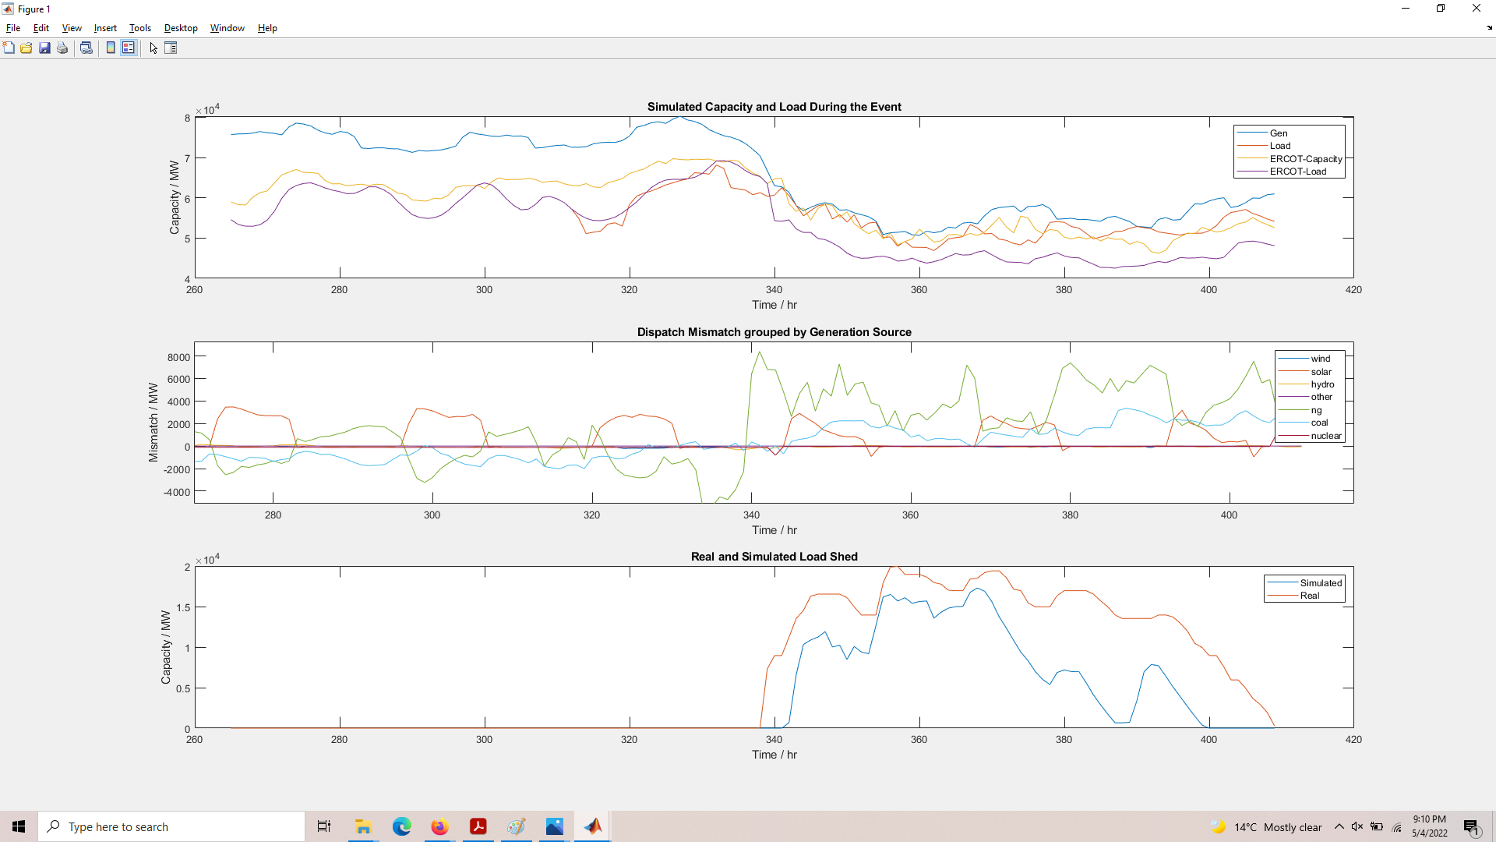

Total Load Shed in MWh:

5.3512e+05

Reduced Load Shed in MWh:

394525

Peak Load Shed in MW:

17288

Load Shed Duration:

58